# API Token Manual

Fundamentals of Generative AI for Item Development

Authors: Henry Makinde, Hope Adegoke, Mubarak Mojoyinola

For this training session, we will be using **Google Gemini (Prompting), Hugging Face (Fine-Tuning), Groq (RAG & Agentic AI), and Tavily (Agentic AI)** API keys. All other API key providers are for your information only.

## API Providers and Models

| **Provider** | **Access Type** | **Free Tier** | **Model Examples** | **Key Features** |
| --- | --- | --- | --- | --- |
| Google Gemini | Free Trial | Yes | Gemini 1.5 Flash/Pro | Google’s foundation models |
| Hugging Face | Free/Paid | Yes (limited) | Falcon, Mistral, LLaMA | Wide range of open models |
| Groq | Free | Yes | LLaMA 3, Mixtral | Very fast inference API |
| Tavily | API-based (Search + RAG) | Yes — limited free usage | Tavily Search API | Real-time web search and retrieval for LLMs; integrates with LangChain and Groq |
| OpenAI | Paid | $5 credits | GPT-4, GPT-3.5 | High performance, versatile |
| Ollama (Local) | Free | N/A | LLaMA 3, Phi3, Mistral | Runs models locally, no key needed |

## **Getting Google Gemini API Key**

1. **Sign Up**
   * Visit <https://ai.google.dev>

1. **Get API Key**
   * Click Models. Under Gemini, choose docs

* + Click “Get a Gemini API Key”

* Click “Create an API Key”. A box will pop up then you choose “Create API key in new project”.

Copy the provided key to a secure location.

**Use the Token**

* + Add to .env:
  + GOOGLE_API_KEY=your_google_key_here

## **Getting a Hugging Face API Key**

1. **Sign Up**
   * Visit <https://huggingface.co/> and sign up

1. **Generate Token**
   * Go to **Settings > Access Tokens**

* + Click **“Create new token”,** choose **“read”** access, give it a token name, and click **“Create token”.** Copy the provided key to a secure location.

1. **Use the Token**
   * Add to .env:
   * HF_API_KEY=your_huggingface_key_here

## **Using Groq API (Free LLaMA API)**

1. **Sign Up**
   * Go to <https://console.groq.com>
   * Sign up with using Google or Github

1. **Generate API Key**
   * > API Keys > Create new key

Give it a name and store the provided API key in a safe location.

1. **Supported Models**

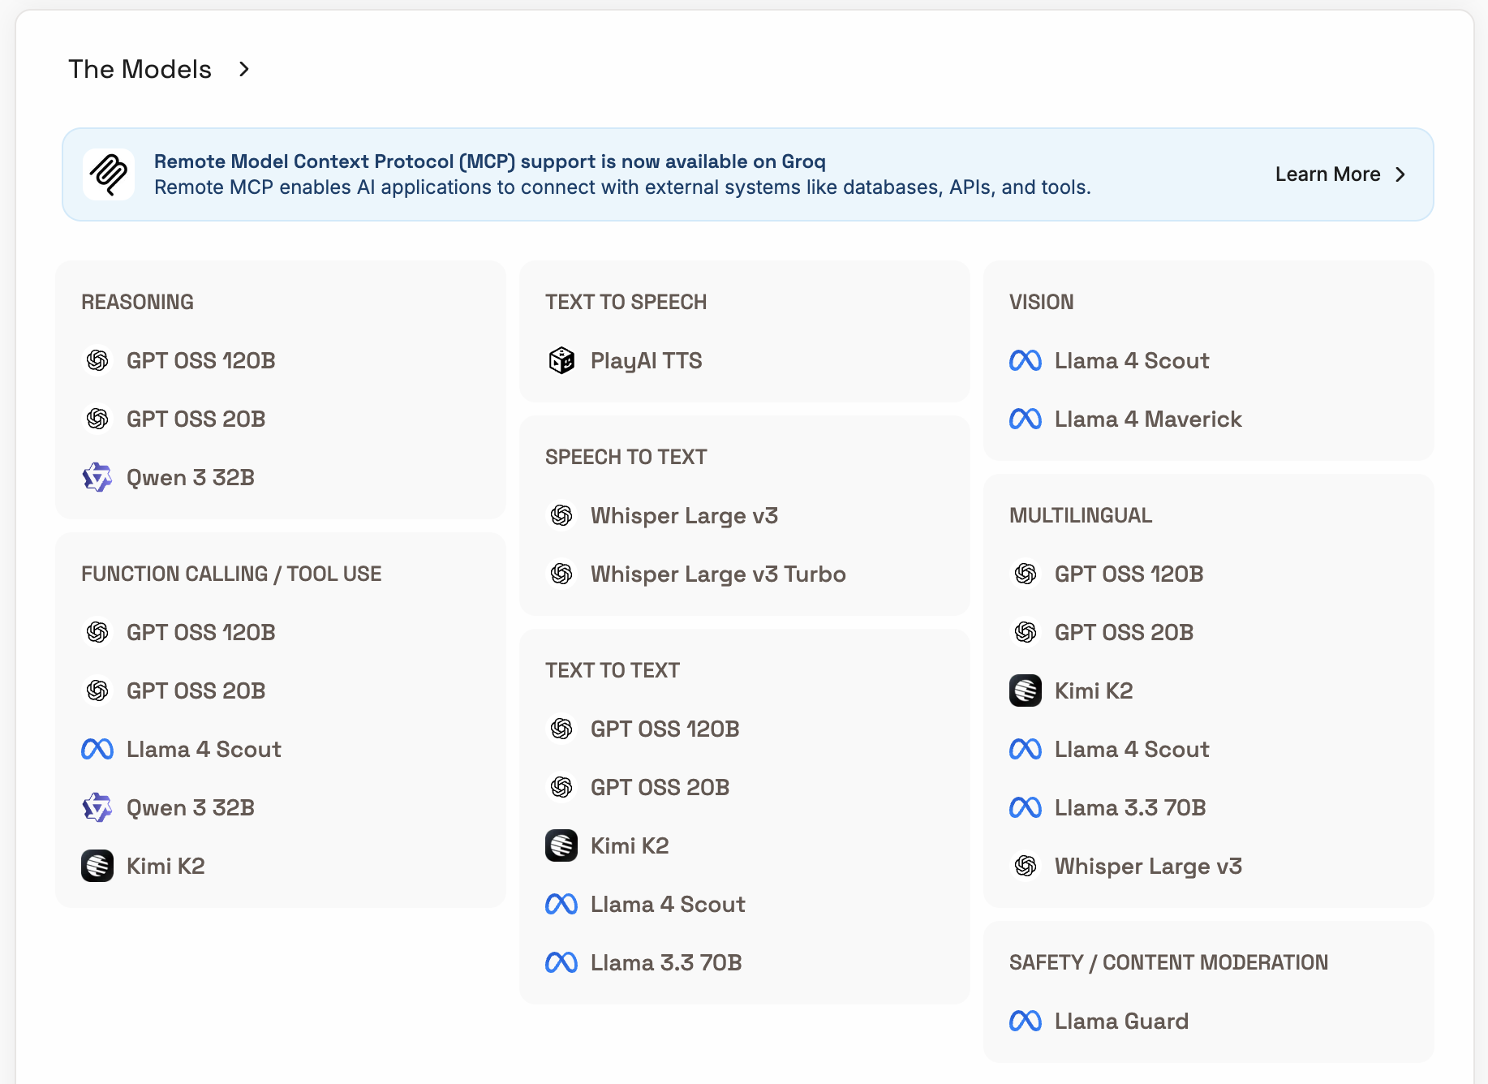

## **Getting a Tavily API Key**

1. **Sign Up**
   * Visit [https://tavily.com/](https://huggingface.co/) and sign up

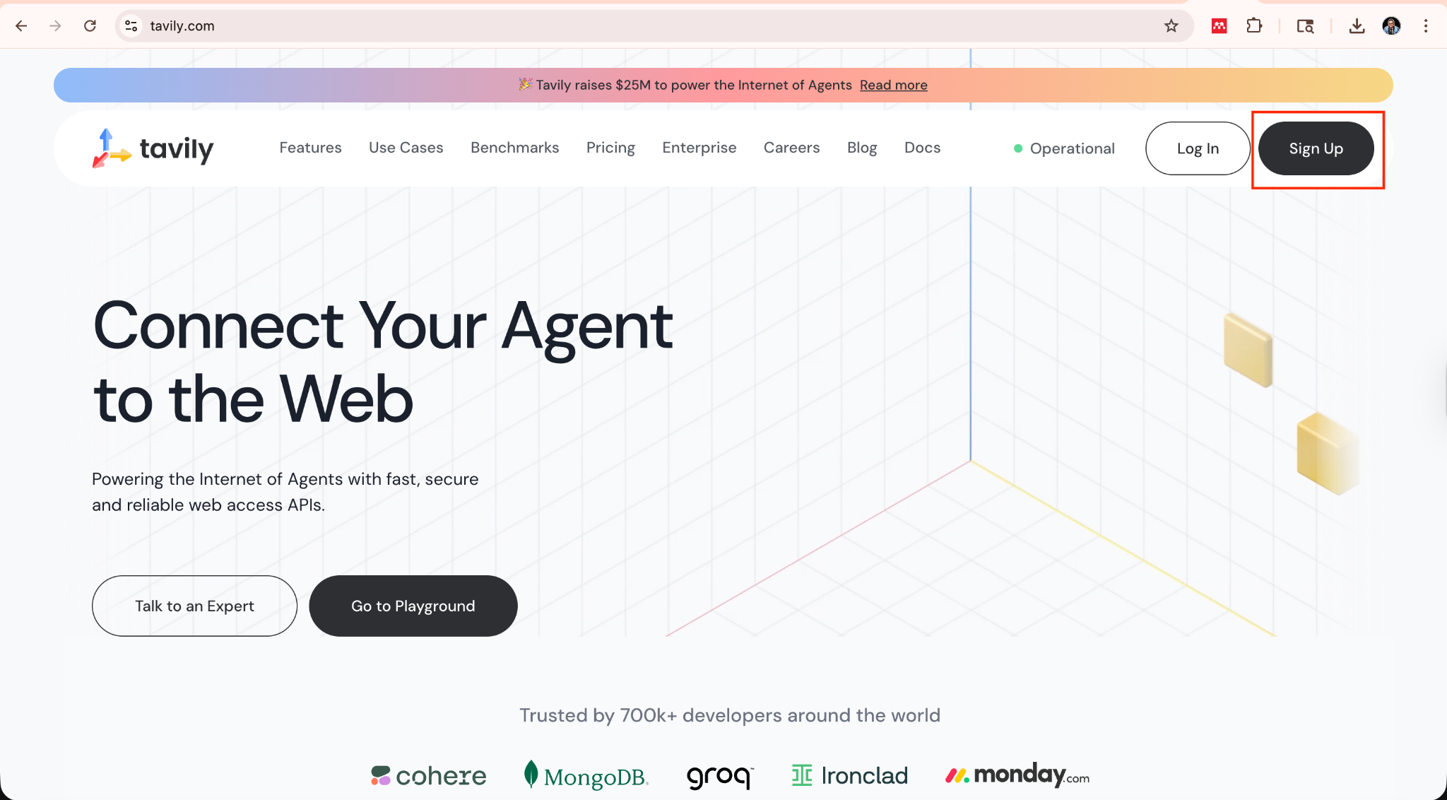

1. **Generate Token**
   * Click on the “+” sign in front of the API Key. A page will pop up to name and create the API key.

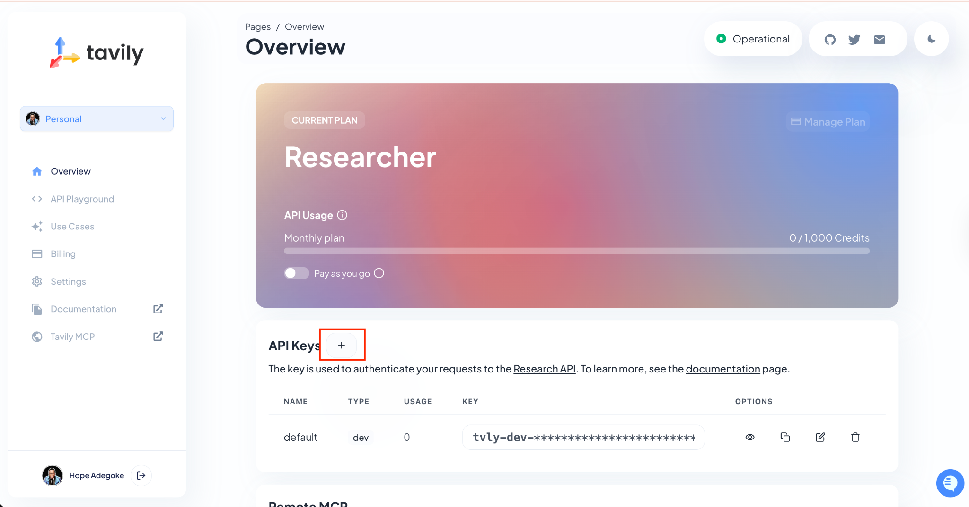

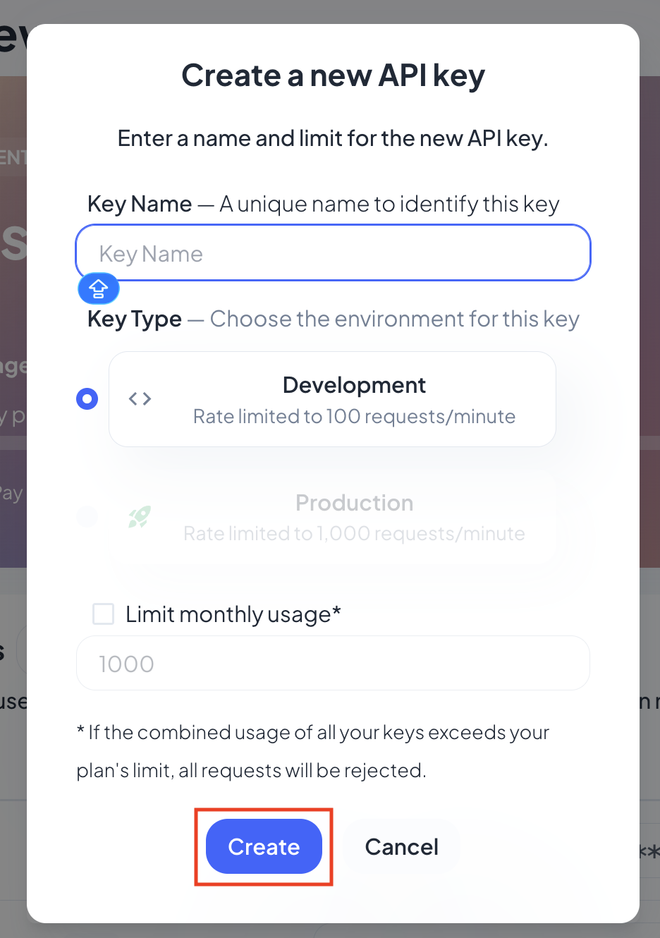

* + After creating, copy the provided key to a secure location..

1. **Use the Token**
   * Add to .env:
   * tavily_API_KEY=your_tavily_key_here

## **Getting an OpenAI API Key**

1. **Sign Up**
   * Go to <https://platform.openai.com/>
   * Sign up using an email address or Google login

1. **Create API Key**
   * Click on your avatar > **“Your profile” > “API Keys”**

* + Click **“Create new secret key”.** Name the key, select **“default project”,** click on Create secret key”, and copy the key to a safe location.

1. **Store Securely**
   * Save in a .env file:
   * OPENAI_API_KEY=your_api_key_here
2. **Note on Pricing**
   * New users get $5 in free credits (valid 3 months)
   * Paid usage starts afterward

## **Ollama: Local Inference (No API Key Needed)**

1. **Install Ollama**
   * Download from <https://ollama.com/download>
2. **Run Model Locally**
   * Use terminal:
   * ollama run mistral
3. **Benefits**
   * Completely free
   * Ideal for private, offline use

## **Best Practices for Managing API Keys**

* **Security:**
  + Never hardcode keys in your scripts
  + Use .env + python-dotenv to manage tokens securely
    - **Load in Python:**
    - Example:
    - **from** dotenv **import** load_dotenv  
      **import** os  
        
      load_dotenv()  
      api_key = os.getenv("OPENAI_API_KEY")
* **Rotation:** Delete old keys and rotate them periodically
* **Version Control:** Never commit .env files to GitHub